**Publish over SSH plugin:**

* If we want to copy the artifacts from Jenkins to remote server
* Install perforce plugin in Jenkins
* Install **publish over SSH plugin** – this connects remote Linux machine and it can perform SSH action as well as the SCP action. So, it can copy the thigs to remote Linux machine and can run the commands on remote machine
* Go to configure settings, under publish over SSH, add server ip, hostname and password

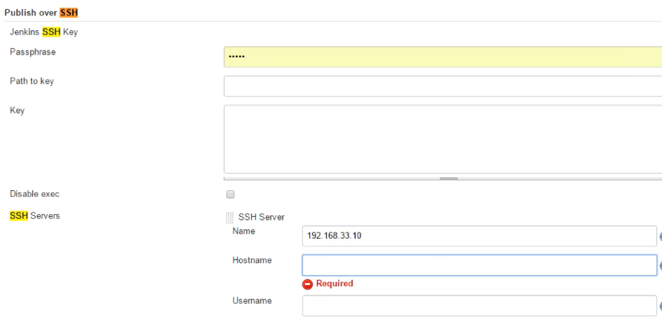

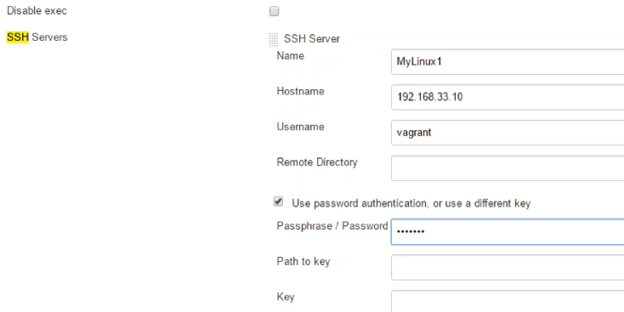

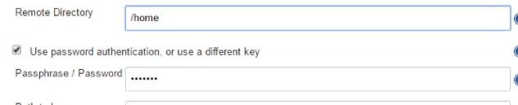

* We can check by clicking on test configuration. Like this, we can configure many more servers
* Now under job configuration, select below option under build section

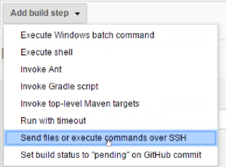

* As per the below image, if there is no such deploy folder in remote directory, it will automatically create one
* And apart from this, if we want, we can execute a command

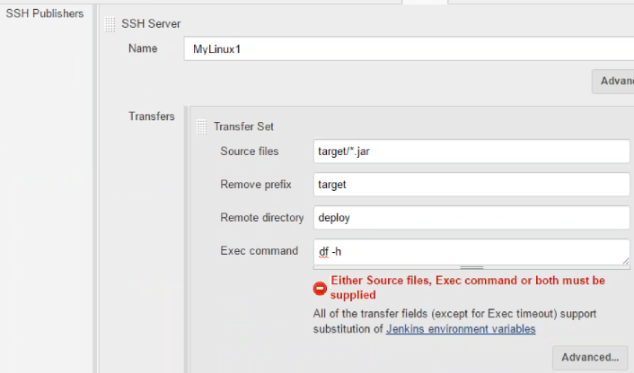

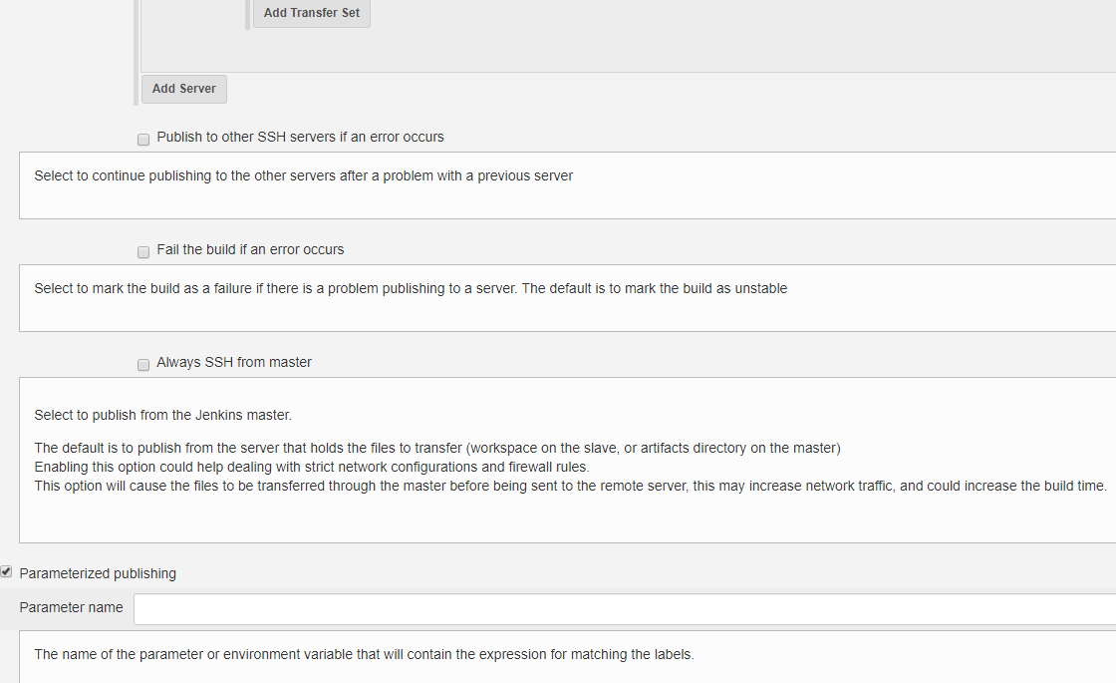

* We can add another transfer set, or we can add more servers
* We can restrict to fail the process if any error occurs in one server, or always do SSH from master server etc.
* We can also add parameterized publishing as above